Lab 5 readme mr.meeseeks

Sensors and Signal conditioning.

In order to get the msp430 board to respond to stimuli from the environment certain sensors and circuit had to be used in order to create, process, and return the signals of various sensors.

ADC

The ADC 10 is a 10 bit code that can be processed on certain board. The msp430g2553 for example handles 10 bit ADC for this application. The number of bits here indicates the divided voltage possible. For a voltage range from 0-5V, the voltage can be divided by 2^-10. This divided voltage value will be returned as a binary value indicating the voltage output based on which circuit was used. The same can be said for ADC 12 on the msp4305994. Which uses 12 bits and can provide more detailed values as a result of more bits available to be used.

Photoresistor

The photo resistor was implemented on all board using the circuit provided. The data board was connected over UART and connected to the msp430 that was then connected to the output pins of each ms430 board (note, the code for functionality between different sensors is similar, the difference between each sensor when applied to the board was based on the sensor used and the circuit it was connected to). In the case of the photoresistor, the photoresistor would continouslly return values over UART that would correlate to the light the photoresistor was receiving. If “FF” was returned over UART, that would indicate no light was reaching the resistor. IF “00” was returned over UART, then that means the photoresistor was returning the maximum value of light that the photoresistor would handle. Photoresistors work on the principal that depending on the amount of light the resistor received, then the resistance value of the resistor would change. This returned value as the circuit passed voltage would indicate the amount of light the resistor was receiving.

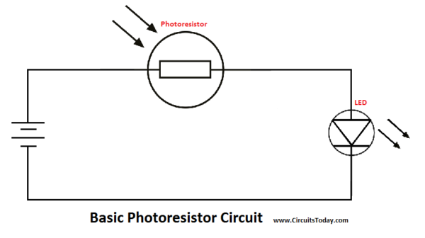

Temperature Sensor,

The lm35 temperature sensor was used in this case. The temperature sensor would would have a different output voltage depending on the indicated temperature. At a rate of 1mv per degree celcius. In this case the 6989 databoard is best used along with an LCD display file in order to output the temperature of the sensor. The code shown below shows the conversion rate based on voltage of the temperature sensor and the output in degrees Celsius.

temperatureDegF = temperatureDegC \* 9.0f / 5.0f + 32.0f;

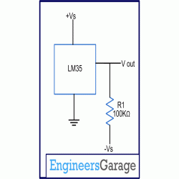

Phototransitor

A phototransistor is similar to a photodiode in that both change resistance based on light, however the phototransistor is more sensitive. In the case of the phototransistor the resistance changed resulted in an increase beyond 250mv on average when compared to the same light source as the original photodiode. (same circuit as used for the photodiode)

Implementing the code.

Upload the code as per the main.c files for each databoard and connect the output pin (as commented in the code) to the input of each sensor circuit.